32.25: 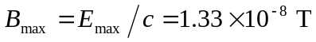
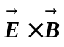 is in the direction of propagation. For 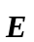 in the +-direction, 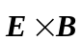 is in the +-direction when 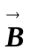 is in the +-direction.

